**Learning objectives class 6: Sex determination**

**By the end of this topic you should be able to:**

* **Describe the different sex determination systems; X-Y, Z-W, X-O, and give examples of organisms that use each system**

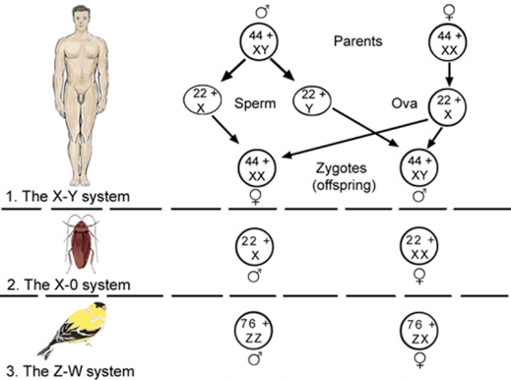

* **Distinguish between sex determination and sex differentiation**

**Differentiation Determination**



* **Very briefly describe how environmental factors such as temperature can affect sex determination (Temperature dependent sex determination)**

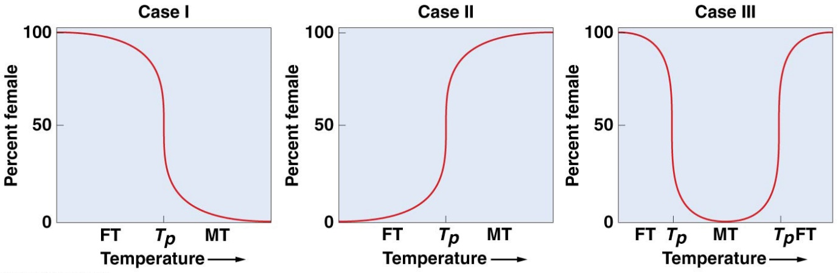

* **Explain how the Y chromosome and the SRY gene are responsible for the development of the male reproductive tract and what can happen when there are errors in this process**

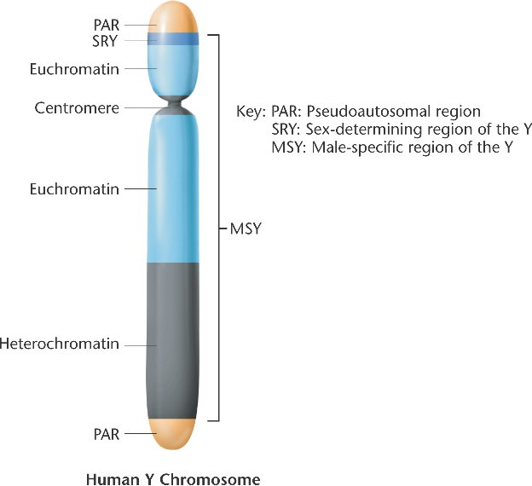

* **Explain why and how X inactivation occurs and this relates to coat colour in tortoiseshell/calico cats**
* **Make sure you understand the basic concept of Barr Bodies**
* 